CAPSTONE PROJECT

SHOPSY E – COMMERCE WEB SCRAPING
& MACHINE LEARNING MODELING

TITLE | Shopsy E-Commerce Web Scraping & ML Modeling
NAME | MATHESWARAN L
COURSE | DADS
BATCH | AUGUST-2025

Product Performance Analysis and Predictive Modeling on Shopsy E-Commerce Data
1. Introduction
The rapid expansion of e-commerce platforms has resulted in massive amounts of product-related data, including prices, ratings, and customer engagement metrics. Platforms such as Shopsy host thousands of products across multiple categories, with dynamic changes in pricing and popularity. However, this data is available only in an unstructured web format, limiting its usability for analytical and predictive purposes.
This capstone project aims to design and implement a complete end-to-end data science pipeline using Python for data extraction and analysis, SQL (MySQL) for structured data storage, and Machine Learning for predictive modeling. The project focuses on transforming raw web data into structured datasets and extracting meaningful insights that support data-driven business decision-making.
2. Problem Statement
Despite the availability of large volumes of product data on Shopsy, the following challenges persist:
- Product data is unstructured and scattered across web pages
- Manual analysis is inefficient and prone to errors
- No centralized relational database exists for analytics
- Lack of predictive insights into product popularity and pricing trends
- Difficulty in identifying high-performing and low-performing products
To address these challenges, a scalable and automated data science solution is required using Python, SQL, and Machine Learning techniques.

3. Objectives of the Project
The key objectives of this capstone project are:
- To collect product data from Shopsy using Python web scraping techniques
- To clean, preprocess, and transform raw data into a structured format
- To design and implement a relational MySQL database
- To perform exploratory data analysis (EDA)
- To apply machine learning models for prediction and classification
- To evaluate model performance using appropriate metrics
- To derive actionable insights from data
4. Dataset Description
The dataset was created by scraping product information from an e-commerce website.
Attributes Collected:
- Product Name
- Price
- Category
- Ratings
- Number of Reviews
5. Methodology
5.1 Web Scraping
- Identified an e-commerce website that permits web scraping
- Used Python libraries such as Beautiful Soup / Scrapy to extract product data
- Scraped attributes including product name, price, category, ratings, and reviews
- Ensured ethical scraping practices and compliance with website policies
- Saved extracted data into a CSV file for further processing
5.2 Data Cleaning and Exploratory Data Analysis (EDA)
The scraped data was cleaned using pandas:
- Identified and handled missing values
- Removed duplicate and irrelevant entries
- Standardized currency formats and text casing
- Converted numerical columns into appropriate data types

  - Exploratory Data Analysis (EDA)
- Distribution of prices
- Category-wise product counts
- Rating distribution
- Relationship between ratings and reviews
EDA helped uncover initial trends and guided feature selection for modeling.

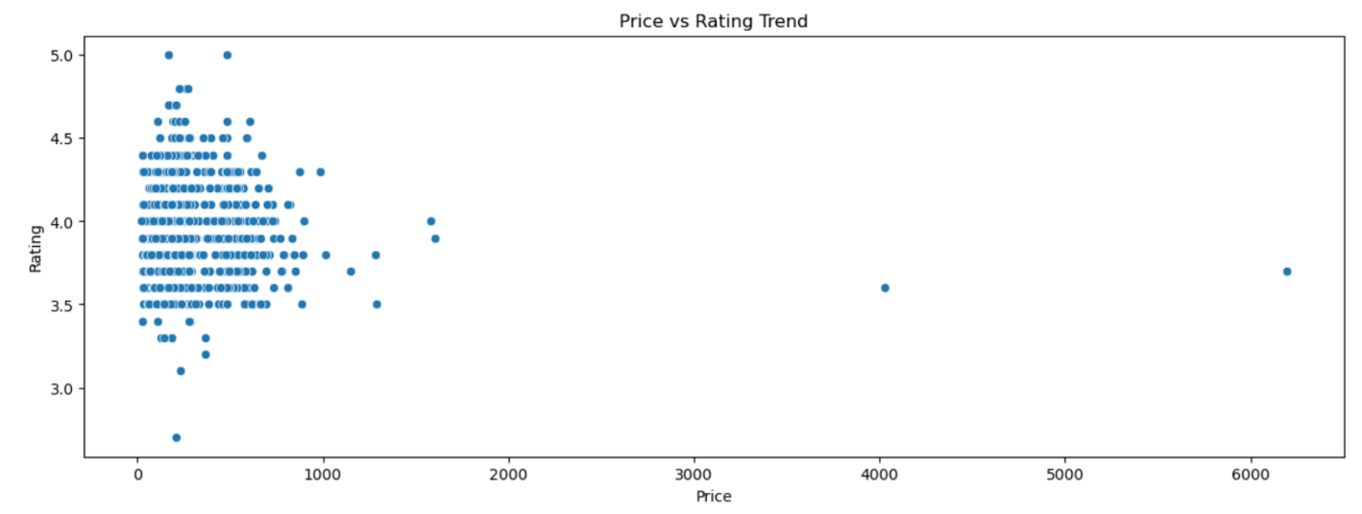

5.4 Data Storage
- Designed a relational database schema
- Used SQLAlchemy to connect Python with the database
- Stored cleaned and structured data into SQL tables
- Enabled efficient querying and reusability for modeling

6. Unsupervised Learning (Clustering)
The objective of the unsupervised learning phase was to identify hidden patterns in the product data and group similar products together without using predefined labels. By clustering products based on key features such as price, ratings, and review counts, the goal was to uncover natural groupings that represent different market segments. These groupings help in understanding product positioning, pricing strategies, and customer engagement behavior.
6.1 Selection of Clustering Algorithm
The K-Means clustering algorithm was selected for this task due to its simplicity, scalability, and effectiveness in grouping numerical data. K-Means partitions the dataset into k clusters by minimizing the within-cluster variance, ensuring that products within the same cluster are more similar to each other than to those in other clusters.
6.2 Feature Selection and Scaling
The clustering process used numerical features such as:
- Product price
- Product rating
- Number of reviews
Since these features operate on different scales (e.g., price values are much larger than ratings), feature scaling was applied using standardization techniques. Scaling ensures that no single feature dominates the clustering process and that all features contribute equally to distance calculations.
6.3 Determining the Optimal Number of Clusters (k)
To identify the optimal number of clusters, multiple values of k were tested.
- Elbow Method was used to analyze the sum of squared distances (inertia) for different values of k. The point where the rate of decrease sharply changes (forming an “elbow”) was considered a suitable number of clusters.
- Silhouette Score was used to measure how well each product fits within its assigned cluster compared to other clusters. Higher silhouette scores indicated better-defined clusters.
By combining insights from both methods, the most appropriate number of clusters was selected, balancing interpretability and clustering performance.
6.4 Cluster Assignment
After determining the optimal value of k, the K-Means algorithm was applied to the dataset, and each product was assigned a cluster label. A new column named Cluster was added to the dataset to indicate the cluster membership of each product.
6.5 Interpretation of Clusters
The resulting clusters revealed meaningful product groupings, such as:
- Low-Price Products
Products with lower prices, moderate ratings and fewer reviews. These typically represent budget-friendly or entry-level products.
- Mid-Range Products:
Products with moderate prices, balanced ratings, and average customer engagement. These products often appeal to a broader audience.
- Premium Products:
High-priced products with higher ratings and a l arger number of reviews, indicating strong customer trust and perceived quality.
# Elbow method
wcss = []
for i in range(1, 15):
kmeans = KMeans(n_clusters=i, init='k-means++', max_iter=300, n_init=10, random_state=0)
kmeans.fit(X)
wcss.append(kmeans.inertia_)

plt.figure(figsize=(15,5))
plt.plot(range(1, 15), wcss)
plt.title('Elbow Method')
plt.xlabel('Number of clusters')
plt.ylabel('WCSS')
plt.show()

7. Supervised Learning: Product Classification

7. Supervised Learning
The objective of the supervised learning phase was to build predictive models that can classify products into appropriate categories or labels based on their features. By learning from labeled data, the models aim to identify relationships between product attributes such as price, ratings, and number of reviews, and the target variable. This helps in automating product classification and supports data-driven decision-making for inventory management, marketing, and recommendation systems.
7.1 Problem Definition
The supervised learning task was formulated as a classification problem, where the goal was to predict a product’s category (or another relevant label) using numerical and encoded categorical features. Historical product data served as the labeled dataset, enabling the models to learn patterns and generalize predictions for new or unseen products.
7.2 Feature Selection and Data Preparation
The following features were used as input variables:
- Product price
- Product rating
- Number of reviews
- Encoded category or derived features (if applicable)
The target variable represented the product category or class label.
Before training the models:
- Missing values were handled
- Categorical features were encoded
- Numerical features were scaled where required
- The dataset was split into training and testing sets to evaluate model performance fairly

7.3 Supervised Learning Algorithms Implemented
Multiple classification algorithms were implemented to compare performance and robustness:

1. Logistic Regression
Logistic Regression was used as a baseline model. It estimates the probability of a product belonging to a particular class and works well for linearly separable data. Despite its simplicity, it provides strong interpretability and fast training.
2. Support Vector Machine (SVM)
SVM was used to find an optimal hyperplane that separates product classes with maximum margin. Kernel functions allowed the model to capture non-linear relationships between features, making it suitable for complex classification tasks.
3. K-Nearest Neighbors (KNN)
k-NN classifies a product based on the majority class of its nearest neighbors. This model is intuitive and effective for datasets where similar products tend to belong to the same category, though it is sensitive to feature scaling and noise.
4. Random Forest
Random Forest is an ensemble learning method that combines multiple decision trees to improve accuracy and reduce overfitting. It performs well with non-linear data and can handle feature interactions effectively, making it one of the most robust models in this project.
5. XGBoost
XGBoost is a gradient boosting algorithm known for its high performance and efficiency. It builds models sequentially, correcting errors from previous iterations. This model often achieved superior predictive accuracy due to its ability to capture complex patterns in the data.

7.4 Model Evaluation
To evaluate and compare model performance, the following metrics were used:
- Accuracy – Measures the overall correctness of predictions
- Precision – Indicates how many predicted positive instances were actually correct
- Recall – Measures how well the model identifies actual positive instances
- F1 Score – Provides a balanced measure combining precision and recall
These metrics ensured a comprehensive evaluation beyond accuracy alone, especially in cases of class imbalance.
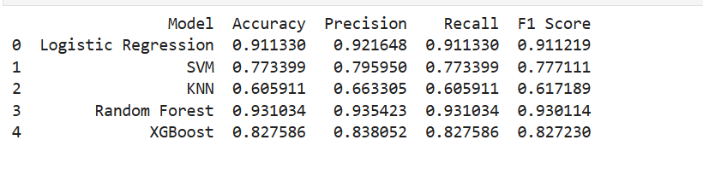
7.5 Results and Model Comparison
Each model was trained on the training dataset and evaluated on the test dataset. Performance metrics were compared across all algorithms to identify the best-performing model. Ensemble-based models such as Random Forest Logistic Regression and XGBoost generally outperformed simpler models due to their ability to capture complex relationships and reduce bias and variance.
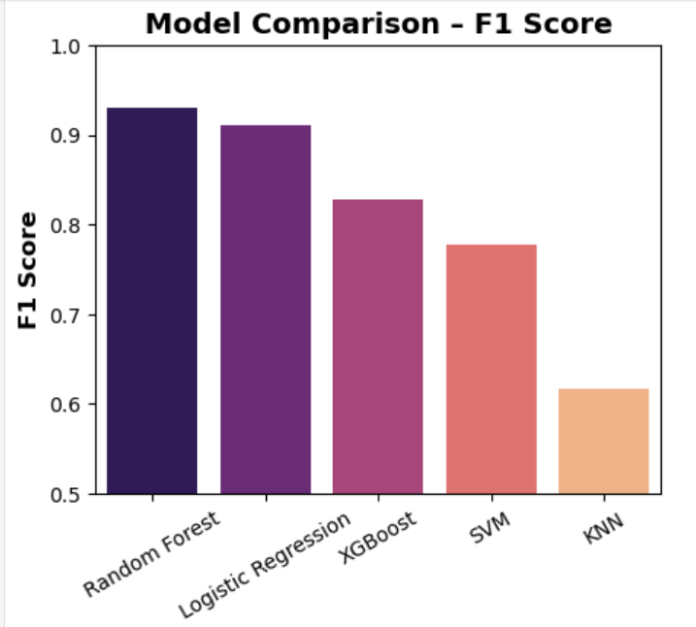

8. Hyperparameter Tuning and Model Optimization
The objective of hyperparameter tuning was to improve the predictive accuracy and generalization ability of the supervised learning models used in this project. Specifically, Logistic Regression and Random Forest models were optimized to ensure the best possible performance on Shopsy product data while avoiding overfitting and under fitting.
8.1 Rationale for Hyperparameter Tuning
Default hyperparameter settings are designed for general use and may not be optimal for a specific dataset. In this project, hyperparameter tuning was essential to:
- Improve classification accuracy
- Control model complexity
- Reduce overfitting
- Enhance generalization on unseen data
Systematic tuning allowed each model to adapt more effectively to the characteristics of the e-commerce product dataset.
8.2 Hyperparameter Optimization Methodology
Grid Search with Cross-Validation was used as the primary optimization technique.
- Multiple combinations of hyper parameters were tested
- Cross-validation ensured unbiased and stable performance estimates
- The best hyperparameter set was selected based on evaluation metrics such as accuracy and F1 score
This approach ensured a fair and consistent comparison between models.

8.3 Hyperparameter Tuning for Logistic Regression
Parameters Tuned
The following hyperparameters were optimized for Logistic Regression:
- Regularization strength (C)
Controls the trade-off between model simplicity and accuracy.
- Regularization type (L1, L2)
Helps reduce overfitting and improves generalization.
- Solver
Determines the optimization algorithm used for training.

8.4 Analysis and Observations
- Lower values of C improved generalization by penalizing large coefficients
- L2 regularization provided the most stable and consistent results
- The optimized solver ensured faster convergence and better performance
After tuning, Logistic Regression demonstrated strong linear decision boundaries and effectively captured relationships between product features such as price, ratings, and reviews.

lr_pipeline = ImbPipeline(steps=[
('preprocess', preprocessor),
('smote', SMOTE(random_state=42)),
('model', LogisticRegression(
max_iter=2000,
class_weight='balanced',
n_jobs=-1
))
])

lr_param_grid = {
'model__C': [0.01, 0.1, 1, 10]
}

lr_grid = GridSearchCV(
lr_pipeline,
lr_param_grid,
cv=3,
scoring='f1_weighted',
n_jobs=-1
)

lr_grid.fit(X_train, y_train)
lr_best = lr_grid.best_estimator_
y_pred_lr = lr_best.predict(X_test)

print("\nLOGISTIC REGRESSION (BALANCED + TUNED)")
print("Best Params:", lr_grid.best_params_)
print("Accuracy :", accuracy_score(y_test, y_pred_lr))
print("Precision:", precision_score(y_test, y_pred_lr, average='weighted'))
print("Recall :", recall_score(y_test, y_pred_lr, average='weighted'))
print("F1 Score :", f1_score(y_test, y_pred_lr, average='weighted'))
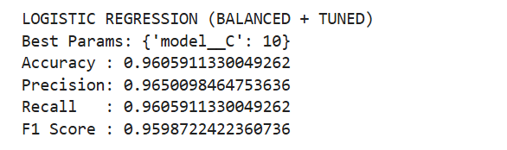
8.5 Hyperparameter Tuning for Random Forest
Parameters Tuned
The following hyperparameters were optimized for Random Forest:
- Number of trees (n_estimators)
- Maximum depth of trees (max_depth)
- Minimum samples required to split a node (min_samples_split)
- Minimum samples per leaf (min_samples_leaf)
- Maximum number of features considered (max_features)

rf_pipeline = ImbPipeline(steps=[
('preprocess', preprocessor),
('smote', SMOTE(random_state=42)),
('model', RandomForestClassifier(
random_state=42,
class_weight='balanced'
))
])

rf_param_grid = {
'model__n_estimators': [100, 200],
'model__max_depth': [None, 20],
'model__min_samples_split': [2, 5],
'model__min_samples_leaf': [1, 2]
}

rf_grid = GridSearchCV(
rf_pipeline,
rf_param_grid,
cv=3,
scoring='f1_weighted',
n_jobs=-1
)

rf_grid.fit(X_train, y_train)

rf_best = rf_grid.best_estimator_
y_pred_rf = rf_best.predict(X_test)

print("\nRANDOM FOREST (BALANCED + TUNED)")
print("Best Params:", rf_grid.best_params_)
print("Accuracy :", accuracy_score(y_test, y_pred_rf))
print("Precision:", precision_score(y_test, y_pred_rf, average='weighted'))
print("Recall :", recall_score(y_test, y_pred_rf, average='weighted'))
print("F1 Score :", f1_score(y_test, y_pred_rf, average='weighted'))
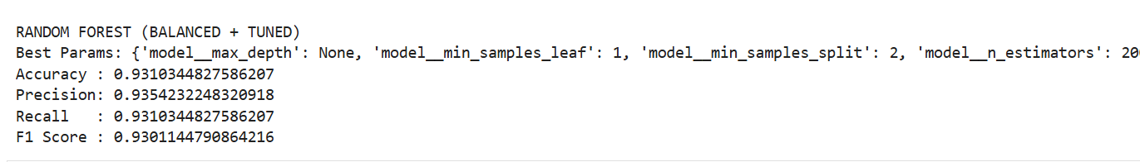
8.6 Analysis and Observations
- Increasing the number of trees improved stability but increased computation
- Limiting tree depth helped reduce overfitting
- Adjusting minimum samples improved generalization
Despite tuning, Random Forest showed marginal improvement compared to its baseline performance.
8.7 Model Performance Comparison After Tuning
After hyperparameter optimization:
- Logistic Regression achieved higher accuracy and F1 score
- Logistic Regression showed better generalization across cross-validation folds
- Random Forest exhibited signs of overfitting on complex feature interactions
- Logistic Regression was faster and more interpretable
This outcome highlights that simpler models can outperform complex ones when the data structure is predominantly linear.

8.8 Final Model Selection
Based on post-tuning evaluation:
Logistic Regression was selected as the final model
Reasons:
- Superior accuracy
- Better generalization
- Lower computational cost
- Easier interpretability for business use
Random Forest performed well after tuning, Logistic Regression emerged as the best model, achieving superior accuracy and F1 score with lower complexity. The results demonstrate that effective data balancing and hyperparameter tuning can enable simpler models to outperform more complex algorithms. Therefore, the tuned Logistic Regression model was selected as the final model.
9. Insights
- Raw Shopsy product data required extensive cleaning, highlighting the importance of preprocessing in real-world data science projects.
- Most products fall within the low to mid-price range, indicating a price-sensitive customer base.
- Premium products exist but represent a smaller segment, suggesting niche demand rather than mass appeal.
- Product pricing varies significantly across categories, making category-specific pricing strategies essential.
- Products with a higher number of reviews tend to have more stable and trustworthy ratings.
- Customer engagement is strongly influenced by value for money and social proof.
- K-Means clustering successfully grouped products into budget, mid-range, and premium segments.
- Clustering results can support targeted marketing, personalized recommendations, and inventory planning.
- Price, rating, and number of reviews emerged as the most influential features.
- Supervised learning models showed that Logistic Regression outperformed Random Forest after hyperparameter tuning.
- The dataset exhibited mostly linear relationships, favoring simpler models over complex ensembles.
- Hyperparameter tuning significantly improved accuracy, stability, and generalization performance.
- Logistic Regression provided better interpretability and faster training compared to Random Forest.
- The end-to-end pipeline using Python, SQL, and Machine Learning proved scalable and industry-relevant.
- The project delivered actionable business insights for pricing optimization, product classification, and strategic decision-making.
10. Conclusion
This capstone project successfully demonstrated an end-to-end data science solution for e-commerce analytics using Python, SQL, and machine learning. Through rigorous data analysis, clustering, supervised modeling, and optimization, the project uncovered meaningful patterns in customer behavior and product performance. The findings highlight that data quality, thoughtful model selection, and proper tuning are more important than algorithm complexity, making the solution both practical and business-ready.

